|  |
| --- |
| chk_captcha |

**Faculty of Computer Science & IT**

**Department of Computer Science**

**Final Year Project**

**PROJECT REPORT (Part-1)**

**[Performance Based Management** **System]**

**Project Team**

|  |  |  |  |  |
| --- | --- | --- | --- | --- |
| **Student Name** | **Student ID** | **Program** | **Contact Number** | **Email Address** |
| Mubeen Liaquat | BCSM-S17-077 | BCSM | 03014024415 | BCSM-S17-077@superior.edu.pk |
| Nouman Sami | BCSM-S17-055 | BCSM | 03040424006 | BCSM-S17-055@superior.edu.pk |
| Hassan Ali | BCSM-s17-063 | BCSM | 03204667538 | BCSM-S17-063@superior.edu.pk |

**Chapter No 1.**

**1 Introduction**

We are providing platform to faculty members to give feedback to the university. The system that was current being used is manually which cause faculty members to submit their feedback at the end of the year. We are providing the efficiency of the system by divided into parts that allows faculty member to submit their feedbacks at the end of months. We are implementing that system which restrict our teachers to submit their feedback at the end of month otherwise they are not be able to mark the attendance of students of next month. We divided yearly system to monthly system. Which reduces the efforts of our teachers, and its also less time consuming to submit their monthly feedback with respect to yearly feedback submission system.

* 1. **Background**

We are developing the website for this system called “**Performance Based Management System**”. The teacher will submit their feedbacks on monthly basis instead of yearly. We make it essential for our teachers to submit their feedbacks otherwise they will be restricted and not be able to marks the attendance of the students until the feedback will be submitted.

* 1. **Motivation And Challenges:**

We are developing this management system for the ease and for the efficiency of time. There is less burden on teachers and less manual effort to put on our system to view the efficient result. Our challenge is to manage our team and divide work in equal parts. So all team members can work easily. And put their best effort on this system to ensure the efficient results.

* 1. **Goals And Objectives**

Our goal is to develop that system and fulfill the requirements of that system. So it will be more efficient to use and less time consuming. This system is capable of reduce the manual work. Team work is a key to success. So we work as a team and we will develop this system in given duration of time.

**1.4 Functional requirements**

User & faculty login**:** User and faculty can login with a registered account.

User & faculty registration**:** User and faculty can be registered themselves.

User posting projects**:** User can post his or her require work with a little description and budget.

Faculty selecting projects**:** Faculty can browse and select from different tasks.

User accepting available faculty**:** User can accept the faculty who wants to work with.

**1.5 Existing Solution**

No online management system available yet.

**1.6 Gap Analysis**

* **Existing**
* Collection of less information.
* Required more time.
* Difficulty in sharing information.
* Difficulty collecting data on daily Bases.
* Difficulty in evaluating staff performance.
* Difficulty in making aware of current situation in less time.
* **New**
* More and easier to gather accurate information.
* Less time required.
* Ease of sharing information.
* Ease of collecting data on daily bases.
* Ease of evaluating staff performances.
* Ease of being aware of current situation in less time.

**1.7 Proposed solution**

* More and easier to gather accurate information.
* Less time required.
* Ease of sharing information.
* Ease of collecting data on daily bases.
* Ease of evaluating staff performances.
* Ease of being aware of current situation in less time.
* Teacher’s performance management system is a continuous process for identifying, evaluating and developing the work performance of teachers, so that the goals and objectives of the institute are more effectively achieved, while at the same time benefiting teachers in term of recognition of performance, professional development and career guidance.

**1.8 Project Plan**

We are developing a performance based management system for our faculty members, as we know the form that we are developing online is currently in hard form that is given to teachers after a year for their feedback and performance evaluation.

* First we have to gather requirements.
* Then we design our system including database and login page.
* Testing
* Deploy
* **1.8.1 Work Breakdown Structure** 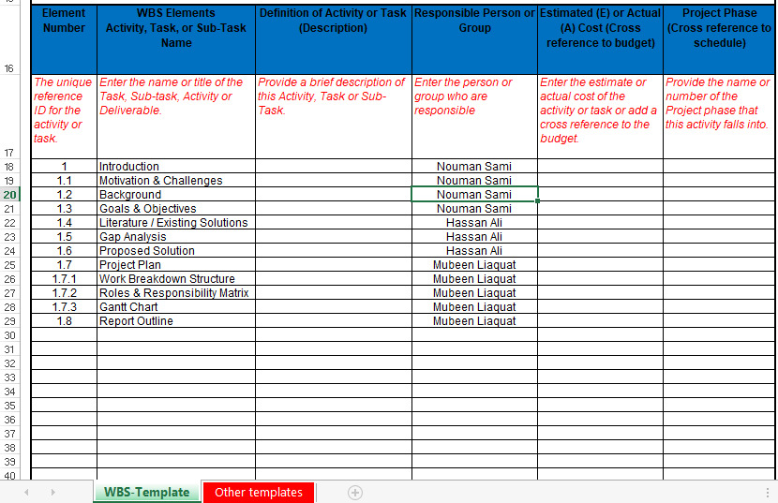

**1.8.2 Role & Responsibility Matrix**

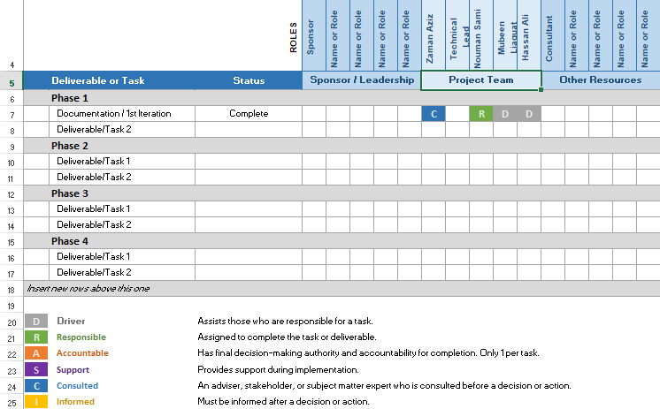

**1.8.3 Gantt Chart**

**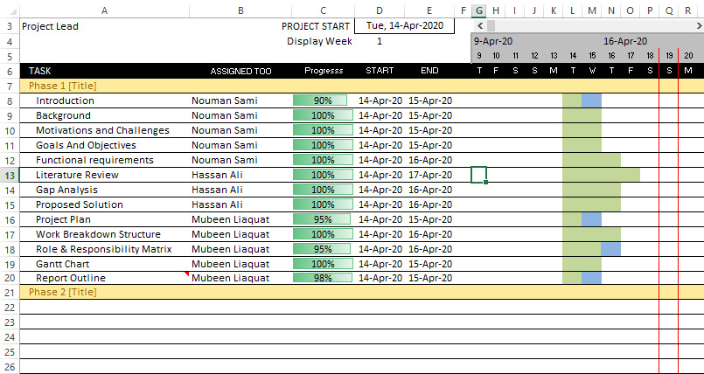**

**1.9 Report Outline**

We are providing platform to faculty members to give performance evaluation to the university. The system that was current being used is manually (Hard Form) which cause faculty members to submit their performance evaluation at the end of the year. We are providing the efficiency of the system by divided into parts that allows faculty member to submit their evaluations at the end of months. We are implementing that system which is easy to use and more sufficient in use. We divided yearly system into monthly system. Which reduces the efforts of our teachers, and it’s also less time consuming to submit their monthly performance evaluations with respect to yearly performance evaluation management system.

**Chapter 2: Software Requirement Specifications**



## Introduction

We are providing platform to faculty members to give feedback to the university. The system that was current being used is manually which cause faculty members to submit their feedback at the end of the year. We are providing the efficiency of the system by divided into parts that allows faculty member to submit their feedbacks at the end of months. We are implementing that system which restrict our teachers to submit their feedback at the end of month otherwise they are not be able to mark the attendance of students of next month. We divided yearly system to monthly system. Which reduces the efforts of our teachers, and its also less time consuming to submit their monthly feedback with respect to yearly feedback submission system.

## Purpose

The purpose of SRS document is to provide a detailed overview of our software product also its parameters and goals. This document provides internal working of software how its work or interact with users of the system. This document describes the projects target audience and its user interface, hardware and software requirements. SRS document helps any designer and developer to assist in software delivery lifecycle (SDLC) processes.

Moreover, this document also has software system constraints, interface and interactions with other external applications and data maintain in database or flow of data.

## Document Conventions

The font style used in this documentation is **Time New Roman** and the font size is **12.**

## 

## Intended Audience and Reading Suggestions

The intended audience of this document includes:

* **Project Manager**

Which use SRS to evaluate the project in all phases of SDLC to evaluate to check project progress going according to Software System requirements or not.

* **Designer**

To make appropriate design flow of the product according to SRS document and architecture of the software system. The software system meets its design according to this SRS document

* **Project Testers**

Will use this document for testing the modules of this software system and for testing strategies as some errors are easier to find using a requirement document.

* **Developers**

Can review the project requirements, its functionalities and try to understand the design and improve its features and functions. It can also act as guidelines for future used.

## References

List any other documents or Web addresses to which this SRS refers. These may include user interface style guides, contracts, standards, system requirements specifications, use case documents, or a vision and scope document. Provide enough information so that the reader could access a copy of each reference, including title, author, version number, date, and source or location.

## User Classes and Characteristics

Identify the various user classes that you anticipate will use this product. User classes may be differentiated based on frequency of use, subset of product functions used, technical expertise, security or privilege levels, educational level, or experience. Describe the pertinent characteristics of each user class. Certain requirements may pertain only to certain user classes. Distinguish the most important user classes for this product from those who are less important to satisfy.

## User Interfaces

## The list below shows the user interfaces that are comprised in WebPages respectively.

**Screens for website**

• Sign in page

• Login page

• Logout page

• Home page

• Services page

• Home view page

• Update/Delete information page

**Functional Requirements:**

* **Employee:**
* Registration
* Log in
* Log out
* Check teacher Assessment
* View Performance paper
* Edit performance paper
* Fill Application form
* Check performance scoring
* **Admin**
* Registration
* Log in
* Log in
* Check Teacher Assessment
* View performance paper
* Fill Application form
* Check Application form
* **Higher bodies**
* Registration
* Log in
* Log in
* Check teacher Assesment
* View performance paper
* Check Application form
* Reply of Application form

## 

## Nonfunctional Requirements

## Performance Requirements

Performance of system is also high as it will response to user request within seconds. The system will not take time on performing any task by the Employee.

## Security Requirements

Regular checks would be applied to the data that would make sure that data is clean in terms of its reliability. Data can be modified on regular basis and progress can also be updated. The website and application will ensure the privacy of patients from one patient to another.

## Software Quality Attributes

The software will be easy to use for employee because of the user friendly interface.

**Chapter 3: Use Case Analysis**

**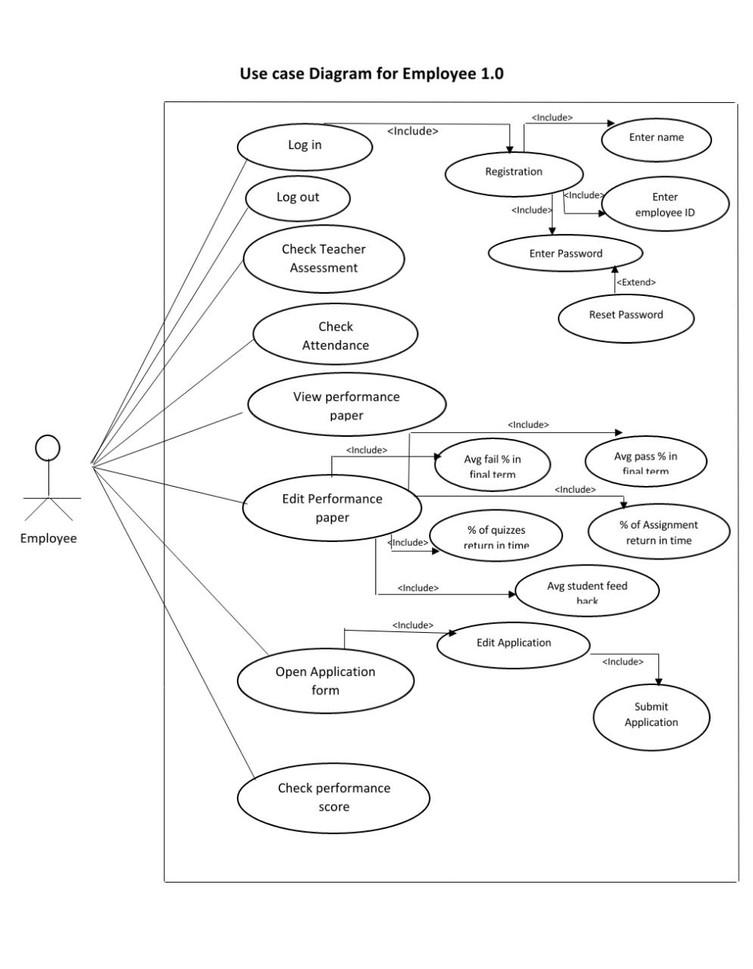**

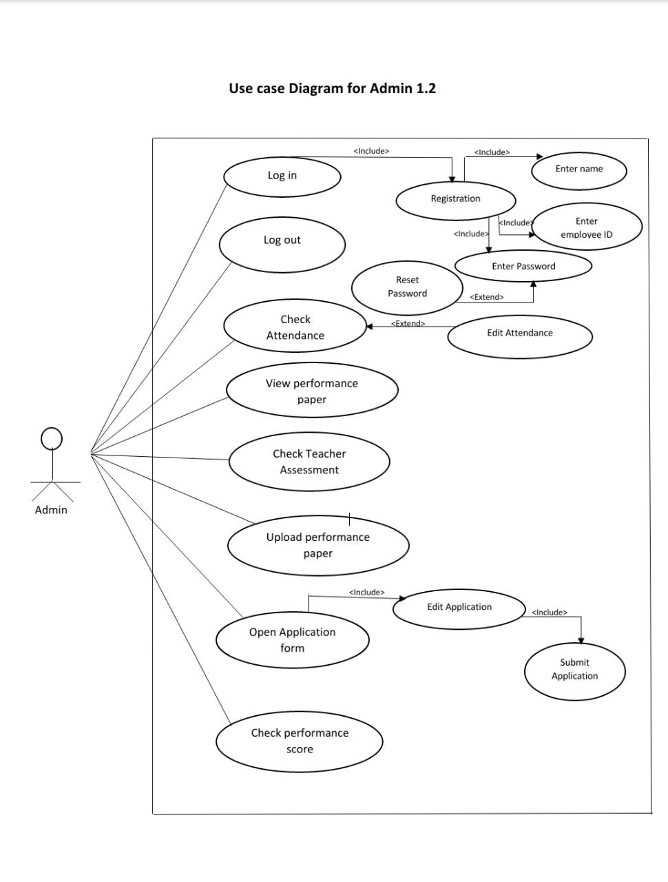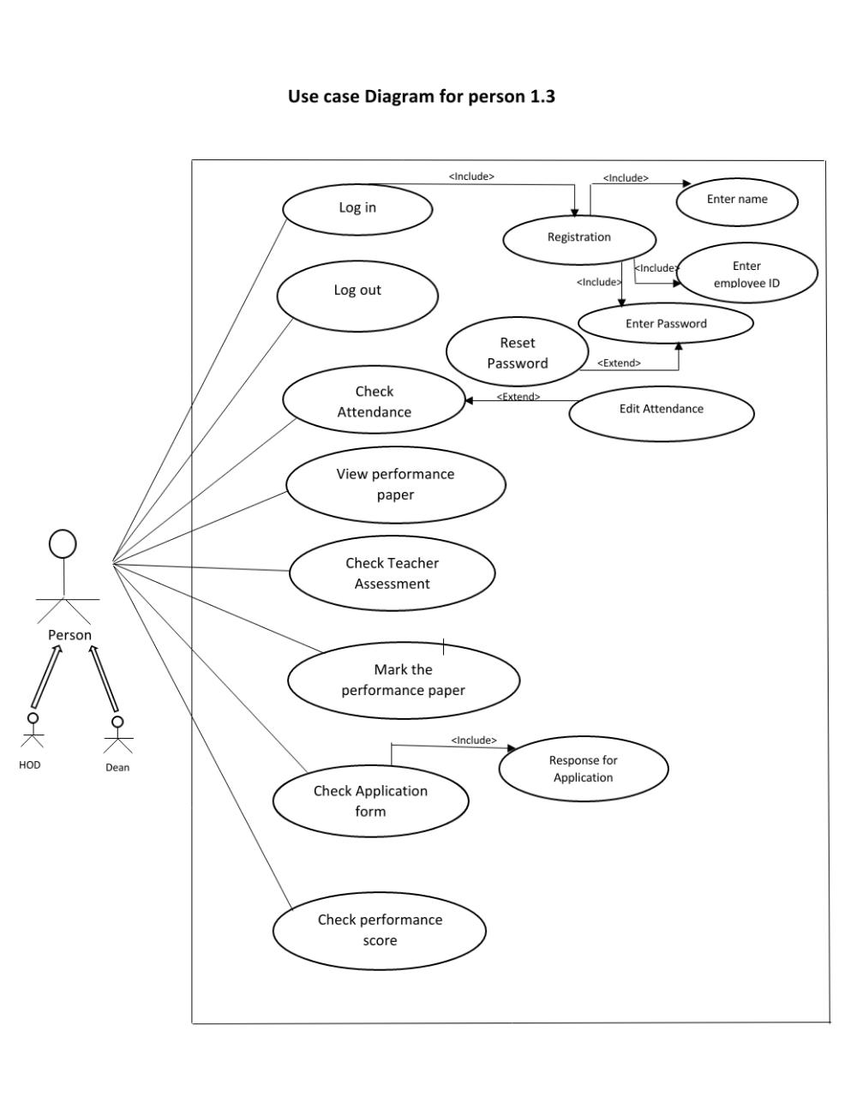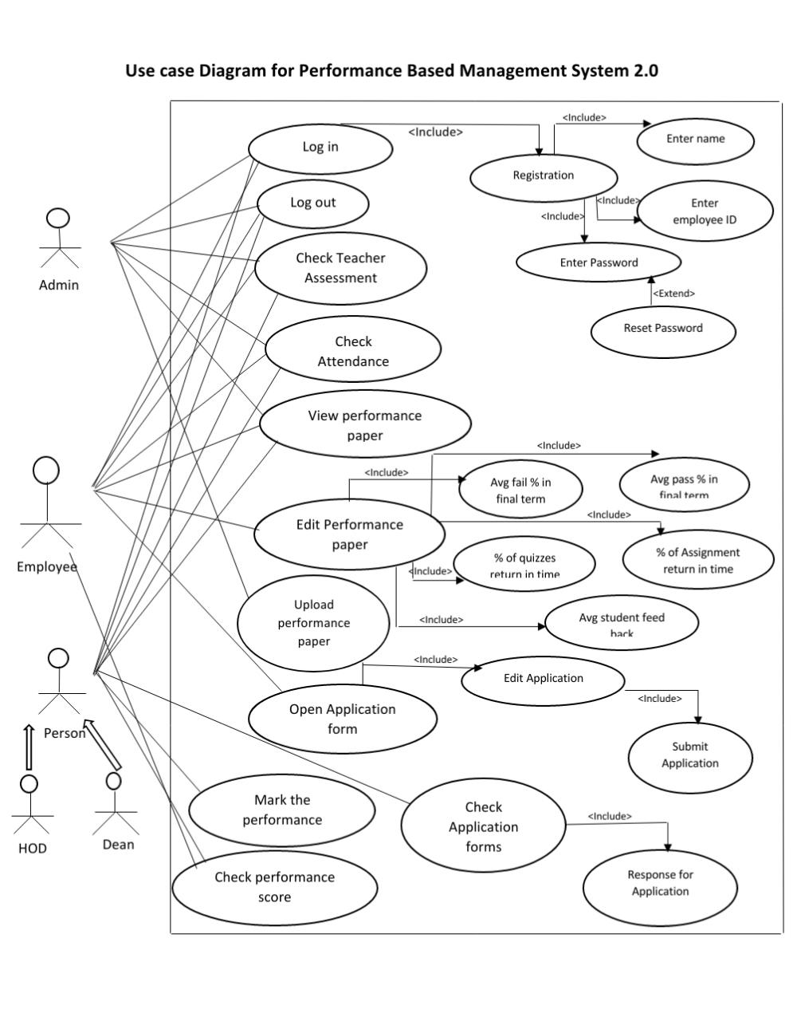

## Specification of Performance based Management System

The right performance management products make it easier to inspire workers to improve their performance. A good process for giving employees feedback on their performance requires far more than just an [annual review](https://www.inc.com/quora/why-performance-reviews-are-way-more-important-than-you-think.html). Fortunately, a performance management product can assist with that. Performance management software makes it easy to provide ongoing feedback to employees and encourage constant improvement. This ability will also help increase employee engagement by providing you with data about which employees are disengaged, making it easy to start a dialogue about where the disconnect is. Tracking performance will also provide you with information about which employees are most effective and which employees may need some help to reach their potential.